**Design and Implementation of a Smart Car Model with Automatic Navigation and Obstacle Avoidance System and Remote-Control Technologies**

**By Junzhe Yan**

**Candidate Number: 238750**

**Supervised by:** **Dr. William Wang**

**A Dissertation Submitted to the**

**Sussex Artificial Intelligence Institute, Zhejiang Gongshang University**

**In Partial Fulfilment of the Requirements**

**For the Degree of**

**BEng Communications Engineering / BEng Robotics & Electrical Engineering**

**Summary**

This project aimed to develop a smart car system equipped with autonomous navigation, obstacle avoidance, and remote-control technologies using multiple sensors and modules. The principal results demonstrated that the smart car could effectively navigate predefined tracks, detect and avoid obstacles, and be remotely controlled, thereby validating the integration of these technologies. However, limitations such as sensitivity to environmental conditions and sensor range were noted. The study concludes that further enhancements in sensor fusion, environmental adaptability, and power management are crucial for improving autonomous vehicle systems. These findings contribute to advancing smart car technology, aligning with the goal of achieving more reliable and efficient autonomous vehicles.

**Statement of Originality**

I confirm by submitting this work for assessment that I am the sole author, and the results are from the design and experiments performed by me. All quotation marks, summaries, and extracts from published sources have been correctly referenced. I declare that this work, in whole or in part has not been previously submitted for publication or for any other award at this or any other institution.

**Statement of Ethics**

In making this submission I declare that my work contains no examples of misconduct, such as plagiarism, collusion, or fabrication of results.

I confirm that I have talked with my project supervisor about whether ethical review will be required, and that the outcome of the discussion is included in my interim report.

Should an ethical review be required, I confirm that I will submit an application before the end of week 2 of the spring term. Furthermore, if the ethical implications of my project change, I confirm that I will alert my supervisor immediately.’

**Contents**

1 Introduction 1

2 Literature Review 2

2.1 Autonomous Navigation Systems 2

2.2 Sensor technologies 3

2.3 Remote control technologies 4

2.4 Current Challenges and Research Gaps 5

3 Method 6

3.1 List materials 6

3.1.1 Hardware 6

3.1.1.1 Main control board 6

3.1.1.2 Four channel tracking module 7

3.1.1.3 K210 vision module 9

3.1.1.4 HC-SR04 ultrasonic sensor 11

3.1.1.5 YDLIDAR X3 LiDAR 12

3.1.1.6 Infrared remote control 13

3.1.1.7 JDY-23 Bluetooth Module 14

3.1.1.8 310 DC Motor 14

3.1.1.9 3D printed car model 15

3.1.2 Software 15

3.1.2.1 STM32CubeIDE 15

3.1.2.2 Visual studio code 16

3.2 Design and Implementation of Experiments 17

3.2.1 Car model assembly 18

3.2.2 Program algorithm for speed control 19

3.2.3 Basic line-following experiment 20

3.2.4 Advanced line-following experiment 21

3.2.5 Basic obstacle avoidance experiment 23

3.2.6 Advanced obstacle avoidance experiment 25

3.2.7 Infrared remote control experiment 26

3.2.8 Bluetooth remote control experiment 27

4 Results 29

4.1 Autonomous Navigation 29

4.2 Obstacle Avoidance 31

4.3 Remote control 32

5 Discussion 35

5.1 Interpreting Results 35

5.2 Limitations 35

5.3 Suggestions for improvements 35

6 Conclusion 36

7 References 36

8 Appendices 38

1. Introduction

The development of smart car systems is crucial due to the rising demand for advanced automotive technologies that enhance safety, efficiency, and convenience. Autonomous vehicles, with automatic navigation and obstacle avoidance, can significantly reduce human error, prevent accidents, and improve traffic management. These technologies are essential for the evolution towards fully autonomous vehicles, which promise safer and more efficient travel.

﻿Research and development in autonomous vehicle technology have been a major focus for decades. The Society of Automotive Engineers (SAE) defines five levels of driving automation, from Level 0 (no automation) to Level 5 (full automation under all conditions). Currently, most commercially available systems operate at Level 2 or Level 3, where vehicles can control steering and acceleration under certain conditions but still require human oversight. Level 4 and Level 5 vehicles, which operate without human intervention, are still in development and testing.

Recent advancements in autonomous vehicle technology include significant improvements in sensor accuracy, data processing algorithms, and machine learning models. These enhancements have enabled better environmental perception, decision-making, and control in autonomous driving systems. However, gaps remain in the integration and performance of these technologies. Many existing systems struggle with complex tasks and dynamic obstacles, and there is a need for comprehensive evaluations of their usability and effectiveness in real-world conditions. Additionally, regulatory frameworks are evolving to support the deployment of autonomous vehicles, with several countries actively developing standards and guidelines to ensure safety and reliability [1]-[3].

This project aims to employing and evaluating autonomous navigation, obstacle avoidance, and remote-control technologies in the autonomous vehicle field. The motivation for this research stems from the growing demand for safer and more efficient autonomous vehicles. By employing and evaluating multiple technologies in a smart car model, the project aims to develop a comprehensive smart car system that integrates multiple functions. The hypothesis is that with various sensors and machine vision, a highly effective and reliable smart car system can be developed.

This project involves designing and implementing a smart car model equipped with autonomous navigation, obstacle avoidance, and remote-control technologies. The car will use infrared sensors for basic navigation and the K210 vision module for advanced navigation tasks. For obstacle avoidance, ultrasonic sensors and infrared sensors will be employed as a basic approach and Lidar will be used as an improved one. And infrared and Bluetooth technologies will be employed in remote control respectively. The effectiveness and usability of these integrated systems will be evaluated through a series of experiments on complex tracks and obstacle scenarios.

1. Literature Review

This section provides an overview of the current state of autonomous vehicle navigation systems, highlighting key research findings, methodologies, and gaps in existing literature. It discusses various technologies and methods used in autonomous vehicle navigation, followed by an analysis of their effectiveness and limitations.

* 1. Autonomous Navigation Systems

Autonomous navigation is a fundamental aspect of autonomous vehicle technology, involving the integration of various sensors, algorithms, and decision-making processes to ensure reliable and accurate navigation. Recent advancements in deep reinforcement learning (DRL) have significantly contributed to the development of sophisticated navigation systems for autonomous vehicles. DRL strategies such as Double Deep Q-Learning and Proximal Policy Optimization (PPO) have shown promising results in optimizing navigation decisions in dynamic and complex environments. These methods enhance the vehicle's ability to learn optimal paths and make real-time adjustments based on environmental feedback, leading to improved navigation success rates [4].

The fusion of supervised learning and reinforcement learning techniques has also been explored to address the challenges of navigating unknown and dynamic environments. A notable approach combines Faster R-CNN for object detection with Double Deep Q-Learning for decision-making. This cooperative method leverages the strengths of both supervised and reinforcement learning to improve the manoeuvrability and efficiency of autonomous vehicles, particularly in environments with unpredictable dynamics. This approach has demonstrated significant potential in real-world scenarios, as evidenced by its successful application in simulated environments [5]

Vision-based systems play a crucial role in autonomous vehicle navigation, utilizing deep learning algorithms to process visual data from RGB cameras. These systems are designed to detect and interpret various road elements, such as lane markings, traffic signs, and obstacles, enabling the vehicle to navigate effectively. A systematic review of deep learning applications in autonomous vehicle navigation highlights the effectiveness of these vision-based systems in enhancing road safety and reducing reliance on complex sensor fusion. By focusing on RGB camera vision, researchers aim to develop cost-efficient and scalable solutions for practical autonomous driving applications [6].

Despite these advancements, several challenges persist in the development of robust autonomous navigation systems. One major issue is the integration of multiple sensor types and algorithms into a cohesive system capable of handling diverse and complex real-world scenarios. Additionally, the high costs associated with advanced sensor technologies, such as LiDAR, pose significant barriers to widespread adoption. Research continues to explore sensor fusion techniques to overcome these limitations, aiming to combine data from various sensors to improve reliability and accuracy [7].

Furthermore, the current navigation systems often struggle with dynamic and unpredictable environments, which can affect their performance. This highlights the need for continued research and development to enhance the adaptability and robustness of autonomous vehicle navigation systems. Comprehensive evaluations of these systems' effectiveness and usability across different conditions are essential to identify areas for improvement and ensure safety and reliability [8].

* 1. Sensor technologies

Sensor technologies are critical components in the development of autonomous vehicles, providing the necessary data to perceive the environment and facilitate decision-making processes. The primary sensors utilized in autonomous vehicles include cameras, LiDAR (Light Detection and Ranging), radar, and ultrasonic sensors. Each of these sensors has unique capabilities and limitations, making the integration and fusion of these technologies essential for robust and reliable autonomous navigation.

Cameras are widely used in autonomous vehicles for visual perception, capturing high-resolution images that are processed using computer vision algorithms to detect and classify objects, lane markings, traffic signals, and pedestrians. Vision-based systems, relying on deep learning techniques, have shown significant advancements in interpreting complex scenes, and enhancing situational awareness [9]. However, cameras are sensitive to lighting conditions and weather, which can impact their performance.

LiDAR technology provides high-resolution 3D mapping by emitting laser pulses and measuring the time it takes for the reflections to return. This creates a detailed point cloud representation of the vehicle's surroundings, enabling precise object detection and distance measurement. LiDAR is highly effective in various lighting conditions and can detect small objects at long distances. However, the high cost and complexity of LiDAR systems pose challenges for widespread adoption [10].

Radar systems are utilized for their ability to detect objects and measure their velocity, particularly in adverse weather conditions where cameras and LiDAR may struggle. Radar operates by emitting radio waves and analysing the reflected signals, making it less susceptible to weather-related interference. Its long-range detection capabilities are crucial for high-speed navigation and collision avoidance [11].

Ultrasonic sensors are primarily used for short-range detection, such as parking assistance and low-speed manoeuvring. They emit ultrasonic waves and measure the time it takes for the echoes to return, providing proximity information. These sensors are cost-effective and reliable for detecting nearby obstacles but have limited range and resolution compared to other sensor types [12].

The integration of these diverse sensors through sensor fusion techniques is crucial to overcoming the limitations of individual sensors and enhancing the overall perception and decision-making capabilities of autonomous vehicles. Sensor fusion combines data from multiple sensors to create a comprehensive understanding of the environment, improving accuracy and reliability. Advanced algorithms and machine learning models are employed to process and interpret the fused data, enabling autonomous vehicles to navigate complex and dynamic environments effectively [13].

Despite the advancements in sensor technologies, several challenges remain. High costs, data processing requirements, and the need for seamless integration are significant barriers. Ongoing research aims to develop cost-effective sensor solutions and improve sensor fusion techniques to enhance the performance and reliability of autonomous vehicles [14].

* 1. Remote control technologies

Remote control technologies play a pivotal role in enhancing the flexibility and safety of autonomous vehicles, especially in scenarios where human intervention is necessary. These technologies allow operators to control vehicles from a distance, providing a backup mechanism in complex or unforeseen situations. Two primary technologies used in remote control for autonomous vehicles are infrared (IR) and Bluetooth, each offering unique benefits and challenges.

Infrared remote-control systems are among the simplest and most cost-effective methods for controlling autonomous vehicles. They rely on the transmission of infrared signals to control various functions of the vehicle. IR systems are typically used for basic control functions due to their limited range and susceptibility to interference from ambient light. Despite these limitations, IR technology is effective for short-range operations, such as parking assistance and low-speed manoeuvres [15]. However, their application in more complex environments is restricted by their need for a direct line of sight and their limited operational range.

Bluetooth remote control systems offer a more advanced alternative to IR systems, providing greater range and reliability. Bluetooth technology enables wireless communication between the vehicle and the control unit over short distances, typically up to 100 meters. This technology supports a wider range of functionalities, including real-time data transmission, which is crucial for remote monitoring and control in dynamic environments. The use of Bluetooth in autonomous vehicles enhances the ability to perform more complex tasks and improves overall system flexibility. However, it also introduces challenges related to signal interference and security, which must be addressed to ensure reliable operation [16].

Teleoperation represents a sophisticated form of remote control where operators can control autonomous vehicles from a considerable distance, often using cellular networks such as 4G or 5G. This approach is particularly beneficial in scenarios requiring human judgment or intervention beyond the vehicle's autonomous capabilities. Teleoperation systems integrate advanced safety features, such as dynamic trajectory planning and collision avoidance, to ensure safe operation despite potential network latencies. For instance, the ATAS (Advanced Teleoperation Assistance System) framework employs real-time data from vehicle sensors to compute safe trajectories and intervene to prevent collisions if necessary [17]. This system ensures that remote operators can effectively manage vehicles even in complex and rapidly changing environments.

Ensuring the security and reliability of remote-control systems is paramount. Technologies like cryptographically secure end-to-end communication are employed to protect data transmission from interception and tampering. Startups such as GetUgo have developed teleoperation solutions that maintain low latency and high security, even on existing network infrastructures. These systems enable the safe and efficient operation of autonomous vehicles in public and industrial settings, promoting broader adoption [18].

* 1. Current Challenges and Research Gaps

The advancement of autonomous vehicles has encountered several significant challenges that continue to impede their widespread deployment and optimal performance. These challenges span technical, ethical, and regulatory domains, highlighting the need for ongoing research and development.

One of the primary technical challenges is ensuring the reliability and robustness of autonomous vehicle systems in diverse and unpredictable environments. Autonomous vehicles must operate effectively under various weather conditions, lighting scenarios, and complex urban settings. For example, LiDAR, while providing high-resolution 3D mapping, can be impaired by heavy rain or fog, and cameras may struggle with low-light conditions or direct sunlight. These limitations necessitate the development of more resilient sensor technologies and advanced data processing algorithms to ensure consistent performance [19].

Another significant challenge is the integration and fusion of data from multiple sensors. Sensor fusion is essential for creating a comprehensive understanding of the vehicle's surroundings, but it also introduces complexities in real-time data processing. Advanced algorithms and machine learning models are required to manage the vast amounts of data generated by sensors such as LiDAR, radar, and cameras. However, the computational demands for real-time processing are substantial, often requiring powerful and expensive onboard computing resources [20].

Human-robot interaction remains a critical area of concern, particularly as most current autonomous vehicle systems are semi-autonomous and require occasional human intervention. Ensuring seamless and intuitive transitions between human and automated control is vital for safety and user acceptance. Effective human-machine interfaces (HMIs) are necessary to manage these transitions and ensure that drivers are adequately prepared to take control when necessary. Studies have highlighted the challenges in alerting drivers promptly and effectively, especially when they are engaged in non-driving activities [21].

Ethical and regulatory issues also present significant hurdles. The deployment of autonomous vehicles involves complex ethical decisions, such as prioritizing the safety of passengers versus pedestrians in unavoidable accident scenarios. Public acceptance of autonomous vehicle technology will depend heavily on the ethical frameworks and regulations established to govern these decisions. Additionally, existing regulatory environments are not fully equipped to address the unique challenges posed by autonomous vehicles, including liability in the event of an accident and standards for vehicle testing and deployment [22].

1. Method
   1. List materials
      1. Hardware

This section will provide a detailed introduction to the main hardware used in the smart car and the main functions of these hardware components.

* + - 1. Main control board

The development of the smart car model for this project is based on the STM32F103ZET6 microcontroller as shown in Figure 1 below, which is a high-performance ARM Cortex-M3 core processor operating at 72 MHz.

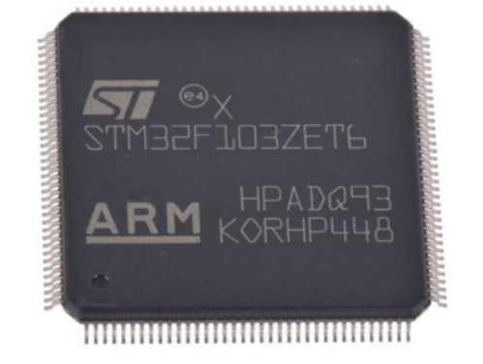

Figure 1 STM32F103ZET6 microcontroller

The STM32F103ZET6 is a 32-bit microcontroller from STMicroelectronics, part of the STM32F1 series. It includes:

* **CPU:** ARM Cortex-M3, operating up to 72 MHz.
* **Memory:** 512 KB Flash and 64 KB SRAM.
* **Peripherals:**
  + **Timers:** 2 basic, 4 general-purpose, and 2 advanced timers.
  + **Communication Interfaces:** 5 UARTs, 3 SPIs, 2 I2Cs, CAN, and USB 2.0 full-speed interface.
  + **Analog Interfaces:** 3x 12-bit ADCs, 1x 12-bit DAC.
  + **Others:** SDIO, FSMC interface for external memory, and multiple GPIOs.

These features enable the microcontroller to handle complex computations, real-time control tasks, and communication with various sensors and actuators used in the smart car system.

To better utilize the STM32F103ZET6 on this smart car, an expansion board has been designed. The STM32F103ZET6 core board is integrated into this expansion board. Below Figure 2 shows the image of the STM32 expansion board.

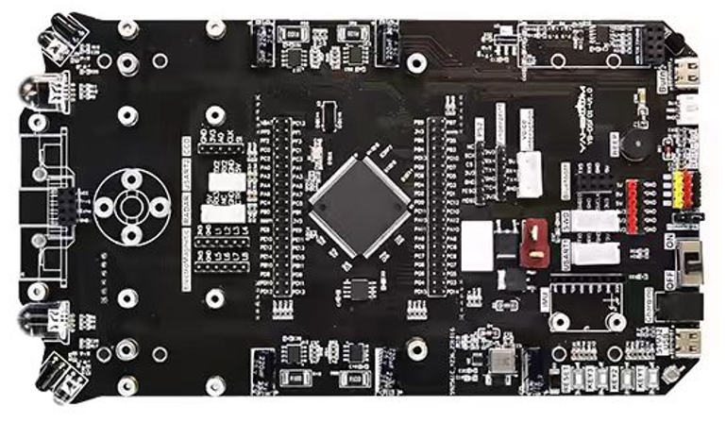

Figure 2 The STM32 expansion board.

* + - 1. Four channel tracking module

The four channel tracking module is primarily used for basic autonomous navigation tasks in the smart car project. It enables the vehicle to follow lines and tracks on the ground by detecting contrasts between light and dark surfaces. This module is essential for implementing reliable line-following algorithms. Below demonstrates the overview and key features of this module:

1. **Basic Parameters:**
   * **Operating Voltage:** 3.3V to 5V (5V recommended for stable operation).
   * **Sensors:** Four infrared sensors configured to detect black lines on a white surface.
   * **Output:** Digital signals corresponding to the presence or absence of a line under each sensor.
2. **Testing the Module:**
   * **Initial Setup:** Connect VCC and GND to the main board and observe the sensors using a camera (infrared light will appear as a faint purple glow).
   * **Operation:** When the module is lifted away from the surface, all four LEDs should be lit. Placing a finger below any sensor will cause the corresponding LED to turn off, indicating sensor detection.
   * **Adjustment:** If any LED does not change state, adjust the sensor’s potentiometer until proper detection is achieved.
3. **Usage in Navigation:**
   * **Environment Requirements:** The module is designed to work best in indoor environments with minimal infrared interference. The track should be a black line on a white surface, with a width of at least 16mm.
   * **Sensor Calibration:** Adjust each sensor’s potentiometer so that the LED turns on when over a black line and off when over a white surface.

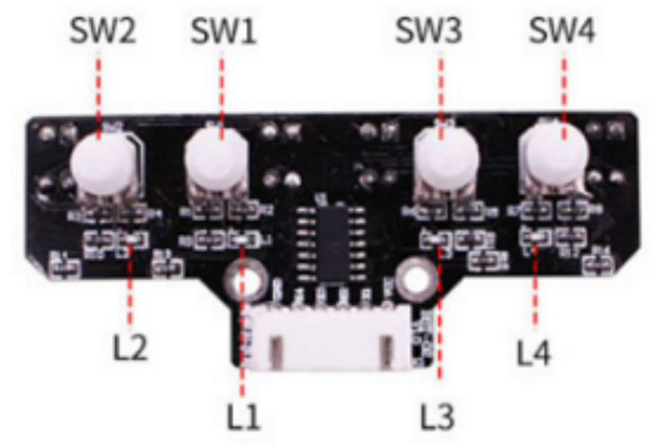

Figure 3 The front side of the four channel tracking module

Figure 3 above shows the front side of the four channel tracking module. SW1 to SW4 are potentiometers used for adjustment. L1 to L4 are LEDs, and when the infrared sensors below them detects the black line, the corresponding lights light up.

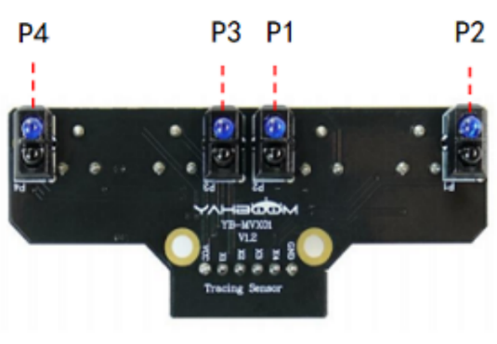

Figure 4 The back side of the four channel tracking module

Figure 4 above shows the back side of the four channel tracking module. P1 to P4 are four infrared sensors.

The four channel tracking module enhances the smart car's ability to follow pre-defined paths, crucial for basic autonomous navigation. By detecting the contrast between the track and the background, the module provides real-time feedback to the microcontroller, enabling precise control of the vehicle’s movements along the track.

* + - 1. K210 vision module

The K210 vision module is a critical component designed to achieve more advanced autonomous navigation capabilities of the smart car. This module leverages advanced AI processing to handle complex tasks such as image recognition and object detection, essential for dynamic path planning in autonomous systems.

The heart of the K210 vision module is the K210 main chip developed by Canaan. This high-performance microcontroller is built on the RISC-V instruction set and includes several advanced features:

1. **Neural Network Hardware Accelerator (KPU):**
   * **Functionality:** The KPU is designed to accelerate the execution of convolutional neural networks (CNNs), providing the computational power needed for advanced AI tasks like image recognition and processing. The KPU can achieve up to 0.8 TFLOPS, significantly enhancing the module's ability to perform real-time image analysis.
2. **Field Programmable IO Array (FPIOA):**
   * **Functionality:** The FPIOA allows developers to map peripherals to any pin, offering great flexibility in hardware design and simplifying the integration process.
3. **Dual-Core CPU:**
   * **Architecture:** The K210 features a dual-core RISC-V 64-bit CPU, with each core equipped with an independent floating-point unit (FPU), which supports efficient floating-point operations crucial for processing complex algorithms.
4. **Machine Vision and Hearing:**
   * **Capabilities:** The chip integrates a convolutional neural network accelerator for machine vision tasks and an audio processing unit (APU) for handling microphone arrays, supporting high-performance visual and auditory processing.
5. **Peripheral Support:**
   * **Variety:** The K210 supports a wide range of peripherals, including DVP (Digital Video Port), JTAG, OTP (One-Time Programmable memory), GPIO, UART, SPI, RTC, I2S, I2C, WDT, TIMER, and PWM, making it highly versatile for various applications.

With the overview of the K210 main chip above, the detailed description of the K210 vision module and its specific applications within the smart car project will be delved into next.

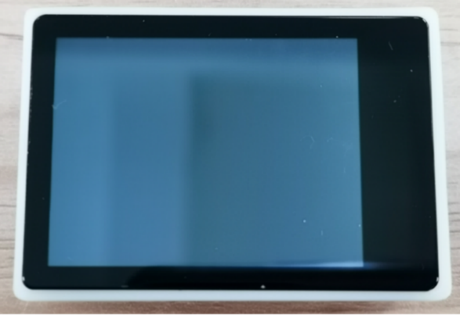

Figure 5 The front side of the K210 vision module.

Figure 5 above shows the front side of the K210 vision module, featuring a 2.0-inch capacitive touchscreen with a resolution of 320x240. Figure 6 below shows the back side of the K210 vision module.

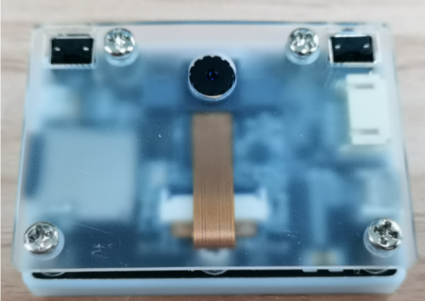

Figure 6 The back side of the K210 vision module.

The K210 vision module's advanced features and components make it highly suitable for enhancing the smart car's autonomous navigation capabilities:

* **Image Processing and Object Detection:** The KPU accelerates image processing tasks, enabling the smart car to detect and classify objects, recognize lanes, and interpret traffic signs with high accuracy and speed.
* **User Interaction:** The capacitive touchscreen allows for direct user interaction, enabling easy control and monitoring of the module’s functions.
* **Storage and Flexibility:** The TF card slot provides ample storage for necessary files, and the customizable button and RGB LED offer additional flexibility in programming and visual feedback.
* **Connectivity and Debugging:** The microUSB interface and external serial port facilitate easy connection to development tools and other devices, streamlining the development and debugging processes.

By integrating the K210 vision module, the smart car can achieve more sophisticated and reliable autonomous navigation, making intelligent decisions based on real-time visual data.

* + - 1. HC-SR04 ultrasonic sensor

The HC-SR04 is an ultrasonic sensor commonly used for distance measurement and obstacle detection in various applications, including autonomous vehicles. It provides precise and reliable distance measurements, making it an essential component for basic obstacle avoidance experiment in the project.

The Figure 7 below shows the physical image of the ultrasonic sensor.

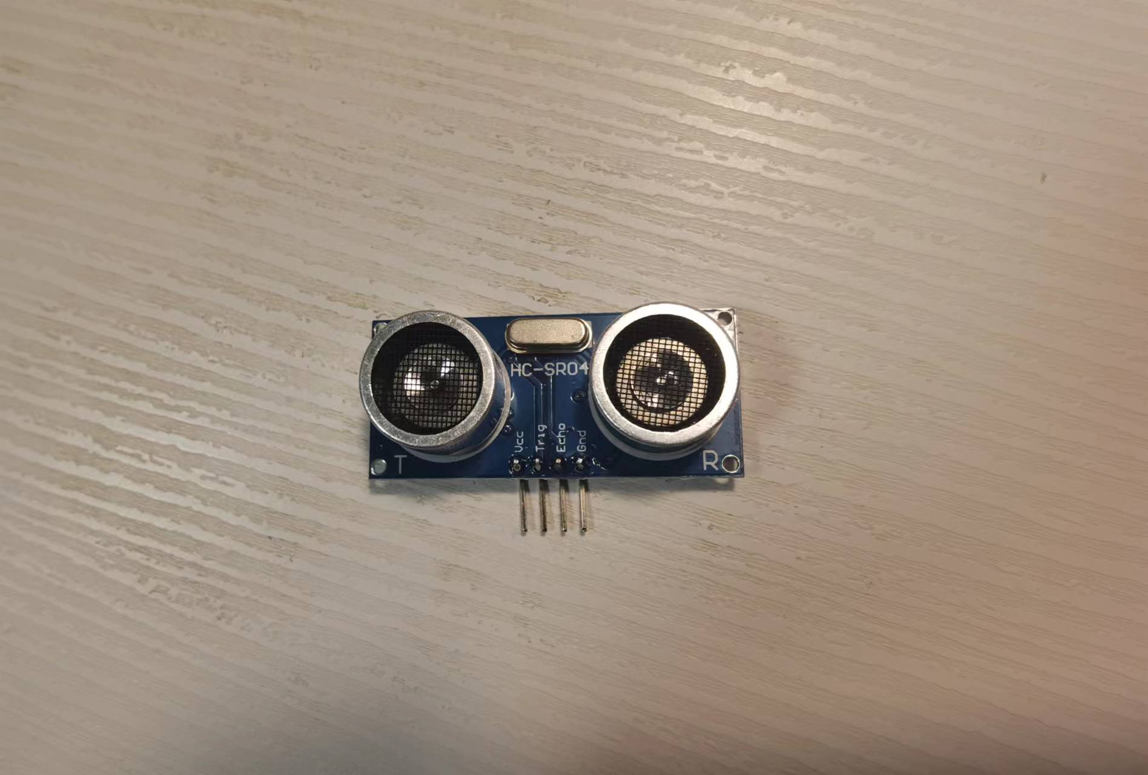

Figure 7 The physical image of the HC-SR04 ultrasonic sensor

The HC-SR04 sensor operates by emitting an ultrasonic wave and measuring the time it takes for the echo to return. This time is then used to calculate the distance to an object based on the speed of sound. The sensor consists of a transmitter and a receiver and is capable of detecting objects within a range of 2 cm to 400 cm. The distance to the object is calculated using the formula as shown in (1) below:

(1)

* + - 1. YDLIDAR X3 LiDAR

The YDLIDAR X3 LiDAR module is a sophisticated sensor integrated into the smart car project to enhance its advanced obstacle avoidance capabilities. This module utilizes Time-of-Flight (ToF) technology to perform precise distance measurements and environmental mapping, allowing the smart car to navigate more complex and dynamic environments effectively. Figure 8 below shows the physical image of the LiDAR.

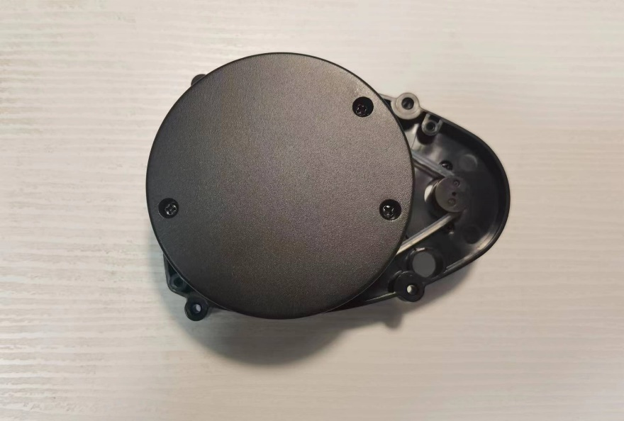

Figure 8 The YDLIDAR X3 LiDAR

The primary purpose of the YDLIDAR X3 LiDAR in the smart car project is to achieve advanced obstacle detection and avoidance. By continuously scanning the environment, it provides detailed distance measurements and point cloud data, enabling the smart car to make informed decisions for safe navigation.

The YDLIDAR X3 is a 360-degree 2D LiDAR sensor designed for high-frequency, high-precision distance measurement. It is based on triangulation and Time-of-Flight (ToF) principles, with a mechanically rotating structure that captures angle information to generate comprehensive environmental scans.

**Key Features**

1. **360° Scanning:**
   * Provides a full 360-degree horizontal field of view, crucial for creating a complete map of the surroundings.
2. **High Precision:**
   * **Measurement Frequency:** 3000 Hz (3000 measurements per second).
   * **Distance Range:** Effective from 0.12 meters to 8 meters, with typical accuracy within ±2 cm for distances up to 1 meter and relative errors of 1% beyond that.
3. **Adjustable Scanning Frequency:**
   * Ranges from 5 Hz to 10 Hz, allowing for a balance between data density and real-time performance.
4. **Power Efficiency:**
   * **Operating Voltage:** 4.8V to 5.2V.
   * **Current Consumption:** Approximately 350 mA during operation, with a maximum of 500 mA when the motor is running.
5. **Environmental Resilience:**
   * **Light Interference Resistance:** Capable of operating effectively in various lighting conditions, making it suitable for both indoor and outdoor use.
   * **Temperature Range:** Operates within 0°C to 40°C, and can be stored in temperatures ranging from -10°C to 60°C.
6. **Communication Interface:**
   * **UART Interface:** Utilizes a UART interface with a baud rate of 115200 bps for data communication.
   * **Motor Control:** Features a PWM input for controlling motor speed, allowing dynamic adjustment of scanning frequency.

By leveraging the advanced capabilities of the YDLIDAR X3, the smart car can perform sophisticated obstacle avoidance tasks, ensuring safe and efficient operation in various scenarios.

* + - 1. Infrared remote control

The infrared remote control system in the smart car project allows for convenient and flexible control of the car’s movements and various functionalities. This system utilizes the HS0038B infrared receiver module integrated in the stm32 expansion board to interpret signals sent from the infrared remote control, translating them into specific actions performed by the smart car. The physical image of the remote control is showed in Figure 9 below.

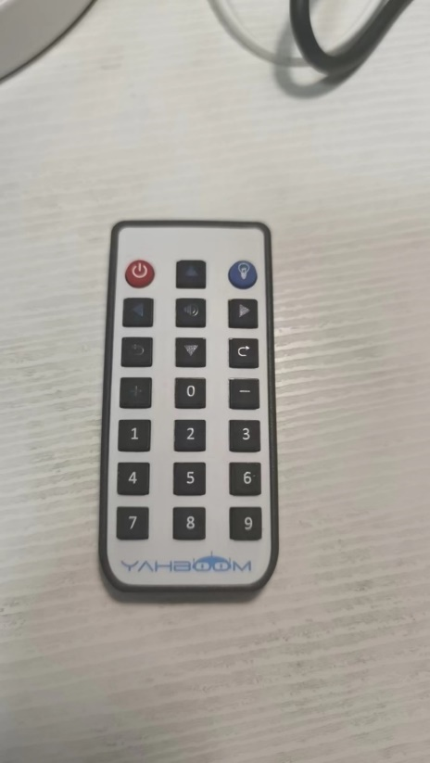

Figure 9 The infrared remote control

The infrared remote control system consists of two main components: the infrared remote control itself and the HS0038B infrared receiver module. The remote control sends encoded infrared signals corresponding to different button presses, which are then received and decoded by the HS0038B module. These signals are used to control various functions of the smart car, such as movement, lighting, and sound.

* + - 1. JDY-23 Bluetooth Module

The JDY-23 Bluetooth module is integrated into the smart car project to provide advanced remote control capabilities. This module uses Bluetooth Low Energy (BLE) 5.0 technology, allowing for efficient, low-power communication between the smart car and a controlling device, such as a smartphone or tablet. The JDY-23 Bluetooth module significantly enhances the smart car's remote control capabilities. The physical images of the module are shown in Figure 10.

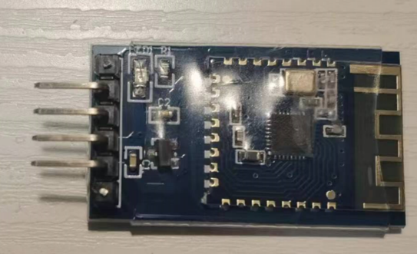

Figure 10 The JDY-23 Bluetooth Module

The JDY-23 is a BLE 5.0 module designed for ultra-low power applications. It facilitates wireless communication over short distances, making it ideal for remote control and data transmission in the smart car project.

* + - 1. 310 DC Motor

The 310 DC motor is widely used in small-scale applications due to its compact size, efficiency, and reliability. In the context of the smart car project, it is utilized for driving the car’s wheels, providing the necessary torque and speed for movement and navigation. Figure 11 below shows the image of the 310 DC motor.

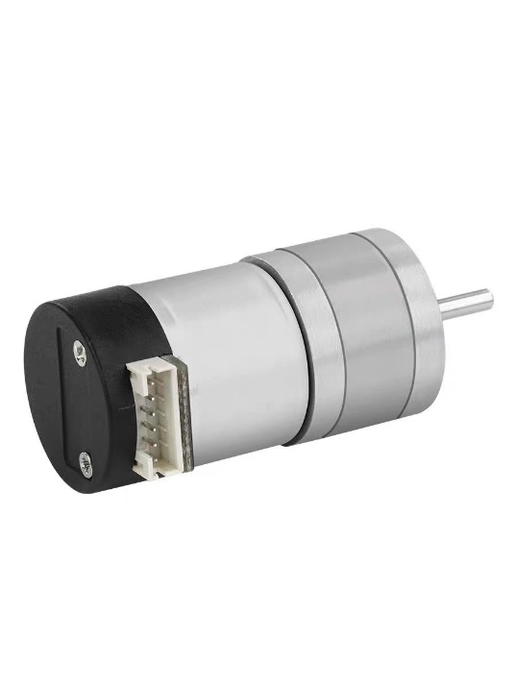

Figure 11 The 310 DC motor

The 310 DC motor is a brushed DC motor known for its simplicity and effectiveness in various applications. It operates on direct current (DC) and consists of a stator, rotor (armature), brushes, and commutator.

* + - 1. 3D printed car model

The smart car project utilizes a 3D printed car model to house and integrate all hardware components, providing a customizable and precise structure for the vehicle. This model is designed to accommodate various sensors, modules, and mechanical parts, ensuring seamless integration and efficient operation.

The 3D printed car model is an integral part of the smart car project, offering a flexible, durable, and customizable platform to integrate and protect all electronic and mechanical components. Its design enhances both the functionality and aesthetics of the smart car, ensuring efficient and reliable operation.

* + 1. Software

In this project, two primary development environments are used: STM32CubeIDE and Visual Studio Code. These tools are essential for programming the STM32 development board and the K210 vision module, respectively. STM32CubeIDE is used for developing C-based programs for the STM32 microcontroller, while Visual Studio Code is utilized for writing Python scripts that run on the K210 module. Below is a detailed description of each software tool.

* + - 1. STM32CubeIDE

STM32CubeIDE is an all-in-one, multi-operating system integrated development environment (IDE) designed by STMicroelectronics for developing applications with STM32 microcontrollers and microprocessors. It combines comprehensive project management, code generation, compilation, and debugging functionalities within a single platform, streamlining the development process for embedded systems.

**Key Features**

1. **Integrated Development Environment:**
   * **Eclipse-based:** Built on the Eclipse/CDT framework, STM32CubeIDE provides a familiar interface for developers accustomed to Eclipse.
   * **Multi-OS Support:** Available for Windows, macOS, and Linux, making it accessible across various development environments.
2. **Project Management:**
   * **STM32 Project Wizard:** Simplifies project creation by allowing users to select the target MCU/MPU, board, or existing example projects.
   * **Automatic Code Generation:** Utilizes STM32CubeMX for peripheral configuration and generates initialization code for the selected STM32 device.
3. **Comprehensive Debugging Tools:**
   * **GDB Debugger:** Integrated with GNU Debugger (GDB) for powerful debugging capabilities.
   * **Advanced Debug Features:** Includes features like live variable monitoring, peripheral registers’ view, memory view, and RTOS-aware debugging for FreeRTOS.
4. **Peripheral Configuration:**
   * **STM32CubeMX Integration:** Provides a graphical interface for configuring MCU peripherals, pin assignments, clock settings, and middleware setup.
   * **Real-Time Updates:** Automatically updates project settings and code based on configuration changes.
5. **Code Compilation and Build Tools:**
   * **GCC Toolchain:** Uses the GNU C/C++ compiler for code compilation.
   * **Makefile Support:** Automates the build process using generated Makefiles.
     + 1. Visual studio code

Visual Studio Code (VS Code) is a free, open-source code editor developed by Microsoft. It is designed to provide a lightweight yet powerful development environment for various programming languages and platforms. Available on Windows, macOS, and Linux, VS Code supports a wide range of programming languages and offers extensive customization through its rich ecosystem of extensions.

**Key Features**

1. **Multi-language Support:**
   * VS Code supports numerous programming languages, including Python, JavaScript, TypeScript, C++, C#, Java, PHP, and more. This makes it versatile for different development needs.
2. **Cross-Platform Compatibility:**
   * Runs on Windows, macOS, and Linux, ensuring a consistent development environment across different operating systems.
3. **IntelliSense:**
   * Provides smart code completions based on variable types, function definitions, and imported modules, significantly enhancing coding efficiency and reducing errors.
4. **Interactive Debugging:**
   * Integrated debugging tools allow developers to set breakpoints, inspect variables, view call stacks, and interact with the running code directly within the editor.
5. **Git Integration:**
   * Built-in support for Git enables users to perform source control tasks such as reviewing diffs, staging files, making commits, and pushing/pulling from repositories without leaving the editor.
6. **Extension Marketplace:**
   * A vast repository of extensions allows users to add support for additional languages, debuggers, themes, and other tools. Extensions run in separate processes to maintain editor performance.
7. **Customization and Extensibility:**
   * Highly customizable with user-defined key bindings, themes, and settings. Extensions can also add new functionality, making VS Code adaptable to various workflows.
   1. Design and Implementation of Experiments

This section provides a detailed explanation of the design and implementation of the experiments for the smart car project. Before conducting these experiments, two crucial steps need to be undertaken: Car model assembly, and Program algorithm for speed control. These preliminary steps are essential to ensure that the car model is correctly assembled and that the basic functionalities, such as speed control, are properly programmed and tested.

* + 1. Car model assembly

The first step before executing the experiments is assembling the smart car model. This process ensures all components are correctly installed and connected, providing a stable platform for subsequent experiments. The assembly includes installing the STM32 development board, 310 DC motors, four-channel tracking module, ultrasonic sensor, K210 vision module, YDLIDAR X3 module, and Bluetooth module.

﻿ The assembly begins by securing the STM32 development board onto the designated mounting area on the car chassis using M3*6mm round head screws, ensuring all ports are accessible. The 310 DC motors are then installed on the motor holders of the chassis and connected to the motor driver module, with proper wiring for power and control signals. Next, the four-channel tracking module is attached to the front of the car chassis, positioned to detect the line on the ground.

﻿ Following this, the HC-SR04 ultrasonic sensor is mounted on the front of the car and connected to the STM32 board. The K210 vision module is then installed on the chassis and connected via the UART interface for data communication. Due to space constraints, the K210 module cannot be installed simultaneously with the YDLIDAR X3 module. Therefore, for experiments requiring the K210 vision module, it will be installed first and later replaced by the YDLIDAR X3 module for obstacle avoidance experiments.

﻿ The JDY-23 Bluetooth module is installed for wireless communication via a mobile application. Finally, the battery is secured to the chassis and connected to the main board, ensuring all components receive adequate power.

﻿ Figures 12 and 13 below show the smart car with the K210 vision module and the YDLIDAR X3 Lidar module, respectively.

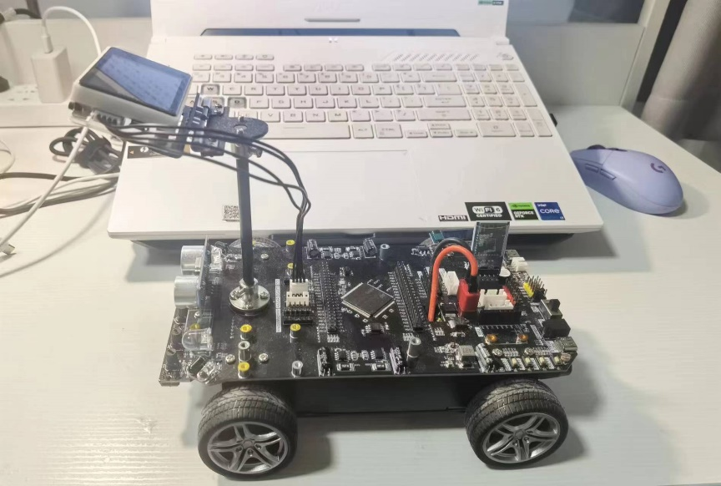

Figure 12 The smart car with the K210 vision module

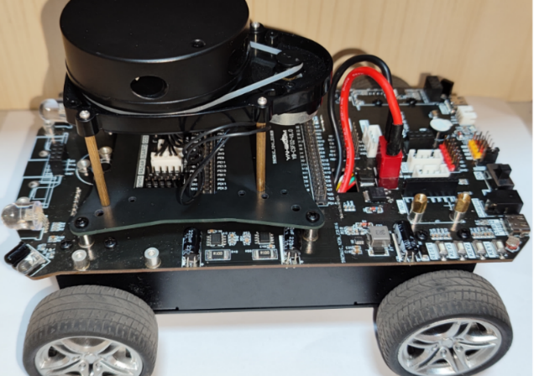

Figure 13 The smart car with the YDLIDAR X3 Lidar module.

* + 1. Program algorithm for speed control

In this project, the speed control algorithm is implemented through a PID controller for the smart car's motors. The PID controller ensures that the motors achieve the desired speed by continuously adjusting the PWM signals based on feedback of the motor speed. The objective of the speed control algorithm is to ensure smooth and accurate speed control of the smart car's motors under various conditions.

The PID (Proportional-Integral-Derivative) control algorithm is used to compute the PWM output that drives the motors. The PID controller minimizes the error between the desired speed and the actual speed of the motors. The PID parameters include the proportional gain (), integral gain (), and derivative gain (). The PID used in this project is the incremental type.

The incremental PID control algorithm involves calculating the error between the desired speed and the actual speed, updating the integral and derivative components based on this error, and computing the PWM output using the PID formula as shown in (2) below:

 (2)

This formula updates the PWM output incrementally based on the current error (), the previous error (), and the error before the last (). The proportional term () responds to the current error, the integral term () accumulates the error over time, and the derivative term () predicts future error based on its rate of change.

The main code for the PID controller is demonstrated in the Appendices A.

* + 1. Basic line-following experiment

The first experiment focuses on enabling the smart car to perform basic line-following tasks using the four channel tracking module. This module is essential for detecting lines on the ground and guiding the smart car along a predefined path.

**Description**

In this experiment, the smart car is placed in a black line on a white surface to test its basic autonomous navigation ability. The track for testing is shown is Figure 14 below.

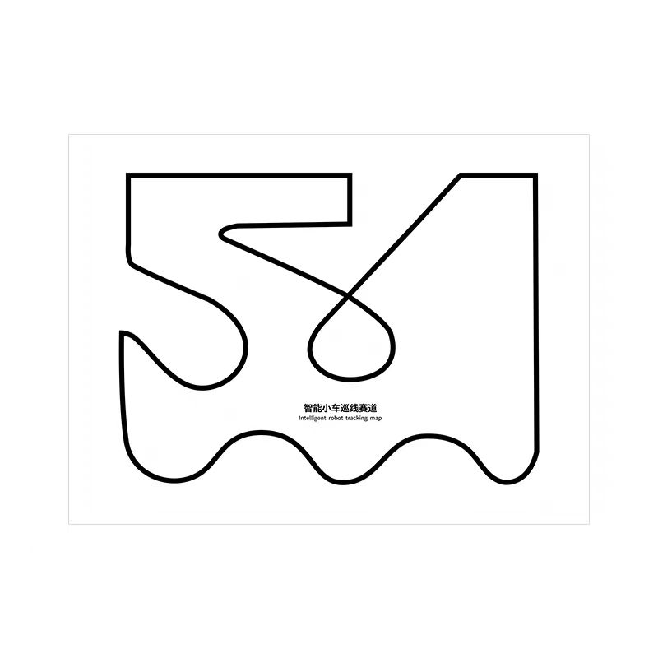

Figure 14 The smart car experimental track

**Experiment Principle**

The smart car uses the four-channel tracking module to obtain real-time position information and adjusts the motor speeds and directions accordingly to follow the line. The four-channel tracking module detects the black and white lines on the path and provides feedback to the STM32 development board:

* When the car veers to the left, the function to turn right is called.
* When the car veers to the right, the function to turn left is called.
* When the car is in the middle, the car moves forward.

The four-channel tracking module detects black lines (low level, LED on) and white lines (high level, LED off) to determine the car's position and adjust its movement. The common detection situations of the four-channel tracking module are shown in the following Figure 15.

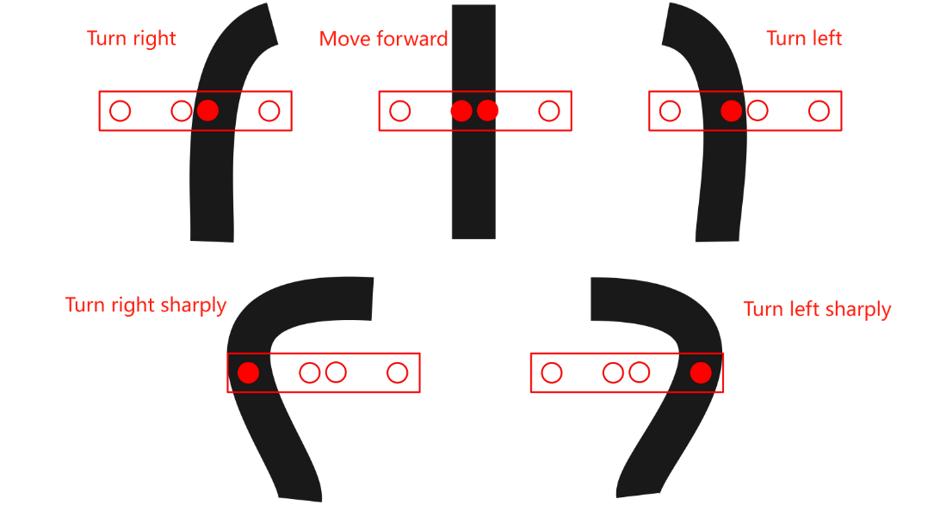

Figure 15 The detection situations of the four-channel tracking module.

The main code for this experiment is included in Appendices B

* + 1. Advanced line-following experiment

The second experiment involves implementing advanced line-following navigation using the K210 vision module. This module leverages image recognition to enable the smart car to follow tracks of various colors. Unlike the previous experiment, the K210 vision module can dynamically learn and adapt to different color thresholds each time the car is started, allowing it to handle different colored tracks.

**Description**

The objective of this experiment is to enable the smart car to autonomously follow lines of various colors using image recognition capabilities of the K210 vision module. This will be tested initially on a black track the same as previous experiment and subsequently on tracks with different colors.

**Experiment Principle**

The advanced line-following experiment utilizes the K210 vision module for real-time image processing and the STM32 microcontroller for motor control. The principle involves several key steps: capturing images, processing the images to detect lines, communicating the line position to the STM32, and using a PID control algorithm to adjust the car's movement.

**Image Recognition Algorithm**

The K210 vision module uses an image recognition algorithm to detect the line on the path. The process involves several stages:

1. **Image Capture**: The camera sensor on the K210 module captures frames of the path at regular intervals.
2. **Color Thresholding**: The captured images are processed to identify the specific colors of the line. This involves defining color thresholds that filter out the pixels corresponding to the line's color. This process is done automatically every time the car is started
3. **Line Detection**: After thresholding, the algorithm fits a line to the detected pixels using regression methods. The function returns the parameters of the detected line, which are then used to determine the line's position within the image.
4. **Center Calculation**: The center of the detected line is calculated to determine the car's relative position to the line. This center coordinate is crucial for the PID control algorithm to adjust the car's trajectory.

The K210 vision module continuously processes images and calculates the line's center position. The coordinates of this center are then sent to the STM32 microcontroller for further processing. Figure 16 below shows the detection of the black track by the K210 visual module. The detected track is outlined in a white box. Figure 17 shows the detection of a colored track.

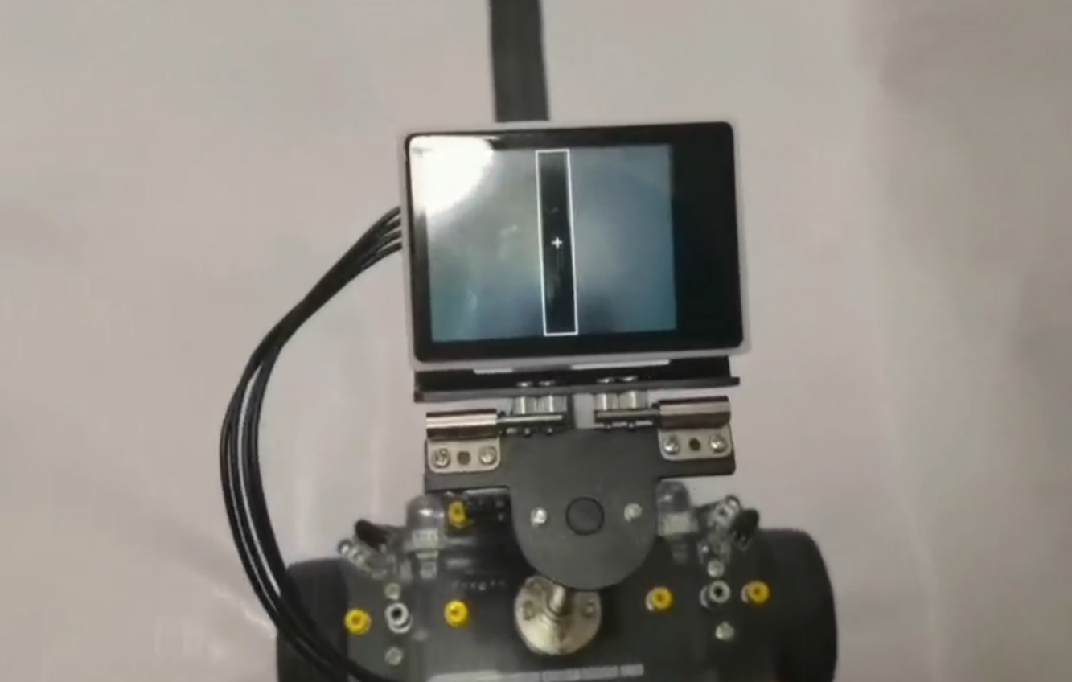

Figure 16 The detection of a black track

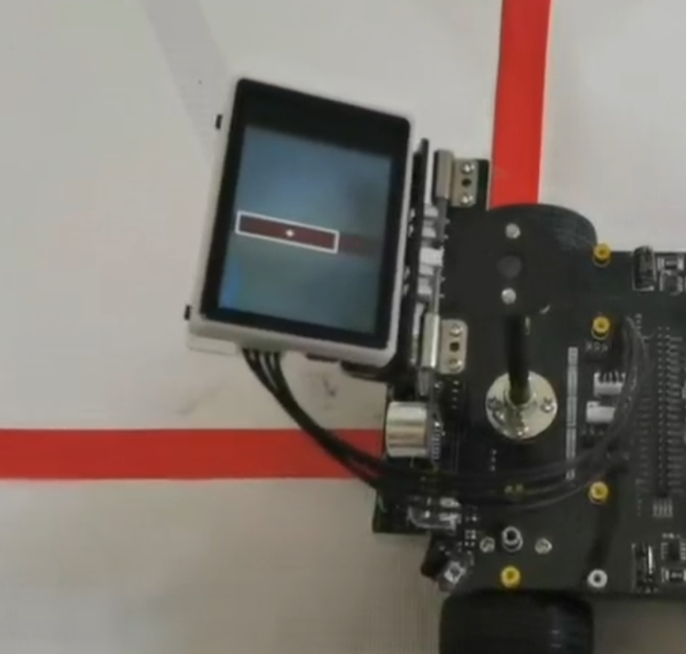

Figure 17 The detection of a colored track

**Control of the Smart Car**

The control of the smart car involves the following steps:

1. **Data Reception and Parsing**: The STM32 microcontroller reads the data frame from the K210 module via UART. Then, the received data frame is parsed to extract the line center coordinate. This involves checking for the start and end markers (**$** and **#**) and converting the coordinate data from a string to an integer.
2. **PID Control**: The extracted coordinate is used as input to a PID controller. The PID controller calculates the necessary adjustments to the motor speeds to minimize the deviation from the line.
3. **Motor Control**: The calculated adjustments are applied to the motors to set the speed and direction of each motor based on the PID output. This ensures the smart car follows the line accurately.

The main code for image processing and car control is demonstrated in Appendices C.

* + 1. Basic obstacle avoidance experiment

The third experiment involves implementing basic obstacle avoidance mechanisms using a combination of ultrasonic and infrared sensors. This experiment aims to enhance the smart car's ability to detect and navigate around obstacles, ensuring safe and efficient movement.

**Description**

The objective of this experiment is to develop and test an obstacle avoidance system that utilizes both ultrasonic and infrared sensors to detect obstacles and adjust the smart car's movement accordingly. The car is placed in a field with different obstacles to test its obstacle avoidance ability.

**Experiment Principle**

The smart car utilizes infrared sensors and an ultrasonic module to detect obstacles. The sensors provide real-time data on the distance to obstacles, which the STM32 microcontroller processes to control the car's movement.

**Obstacle Detection Algorithm**

The obstacle detection algorithm involves the following steps:

1. **Infrared Sensors**: These sensors are used to detect obstacles on the sides of the car. They continuously measure the distance to nearby objects and provide this data to the STM32 microcontroller.
2. **Ultrasonic Module**: The ultrasonic module detects obstacles directly in front of the car. It emits ultrasonic waves and measures the time taken for the waves to bounce back from an obstacle, thus calculating the distance.

**Control Logic**

The control logic for obstacle avoidance is as follows:

1. **Data Acquisition**: The infrared sensors and ultrasonic module collect distance data continuously.
2. **Decision Making**: The STM32 microcontroller processes the sensor data to determine if there are any obstacles within a predefined distance threshold.
3. **Movement Control**:
   * If an obstacle is detected in front of the car (within the threshold distance), the car stops and reverses slightly.
   * The car then checks the distances reported by the side infrared sensors.
   * Based on the side sensor data, the car decides whether to turn left or right to avoid the obstacle.
   * If no obstacles are detected within the threshold distance, the car continues to move forward.

The main code for this experiment is shown in Appendices D.

* + 1. Advanced obstacle avoidance experiment

The fourth experiment focuses on implementing advanced obstacle avoidance using the YDLIDAR X3 module. This module leverages laser scanning technology to detect and measure distances to obstacles, allowing the smart car to navigate complex environments more effectively.

**Description**

The primary objective of this experiment is to enable the smart car to perform more precise obstacle detection and avoidance using the YDLIDAR X3 LiDAR sensor. The car is placed in a field with different obstacles to test its obstacle avoidance ability.

**Experiment Principle**

The smart car utilizes the YDLIDAR X3 lidar sensor to detect obstacles in its surroundings. The lidar sensor provides precise distance measurements by emitting laser pulses and measuring the time it takes for the pulses to return after hitting an object. The STM32 microcontroller processes this data to control the car's movement and avoid obstacles.

**Lidar Obstacle Detection Algorithm**

The obstacle detection algorithm involves several key steps:

1. **Lidar Data Acquisition**: The lidar sensor continuously scans the environment, collecting distance data for various angles around the car. This data is transmitted to the STM32 microcontroller via a serial interface (UART).
2. **Data Segmentation**: The 360-degree scan data from the lidar is divided into specific segments representing different directions around the car:
   * Front: 170° to 190°
   * Left: 70° to 110°
   * Right: 250° to 290°
   * Front-Left: 140° to 170°
   * Front-Right: 190° to 210°
3. **Distance Calculation**: For each segment, the average distance is calculated to determine the presence of obstacles. This involves averaging the distance measurements within each angular segment.
4. **Decision Making**: Based on the calculated distances, the car's movement is adjusted:
   * If an obstacle is detected in the front segment, the car stops and decides whether to turn left or right based on the distances in the left and right segments.
   * If obstacles are detected in the front-left or front-right segments, the car adjusts its path accordingly to avoid the obstacles.
   * If no obstacles are detected within the threshold distances, the car continues to move forward.

**Control Logic**

The control logic for obstacle avoidance is as follows:

1. **Data Reception**: The STM32 microcontroller reads the data frames from the lidar sensor via UART.
2. **Segmentation and Calculation**: The received data is segmented into different angular regions, and the average distance for each region is calculated.
3. **Movement Control**:
   * If the average distance in the front region is below a predefined threshold, the car stops and reverses slightly.
   * Based on the average distances in the side regions, the car decides to turn left or right to avoid the obstacle.
   * If no obstacles are detected within the threshold distances, the car continues to move forward.

The main code for this experiment is shown in Appendices E.

* + 1. Infrared remote control experiment

The fifth experiment involves implementing basic remote control functionality for the smart car using an infrared (IR) remote control. The objective is to allow the smart car to be controlled wirelessly, responding to various commands sent from the IR remote.

**Description**

The objective of this experiment is to enable the smart car to respond to different commands from an infrared remote control. The car is placed in an open field and infrared remote control is used to control the car’s movement, lights, buzzer, speed and so on.

**Experiment Principle**

The smart car utilizes the infrared receiver (HS0038B) to receive signals from the infrared remote control. Each button on the remote control corresponds to a unique signal, which the STM32 microcontroller interprets to perform specific actions.

**Control Logic**

The control logic for the infrared remote control experiment involves several steps:

1. **Signal Reception**: The infrared receiver (HS0038B) receives the IR signal when a button on the remote control is pressed. This signal is encoded as a specific data frame.
2. **Signal Decoding**: The STM32 microcontroller decodes the received data frame to identify which button was pressed. This is typically done using an external interrupt that triggers when the IR signal is received.
3. **Action Execution**: Based on the decoded button value, the microcontroller executes the corresponding action. For example:
   * Moving forward
   * Moving backward
   * Turning left or right
   * Stopping
   * Activating or deactivating LEDs, buzzer, etc.

The actions are implemented using a switch-case structure in the code, where each case corresponds to a specific button value.

The main code for this experiment is shown in Appendices F.

* + 1. Bluetooth remote control experiment

The sixth experiment involves implementing advanced remote control functionality for the smart car using a Bluetooth module. This experiment aims to provide wireless control of the smart car through a mobile application, allowing for more versatile and user-friendly operation.

**Description**

The objective of this experiment is to enable the smart car to be controlled wirelessly via Bluetooth using a mobile application. The car is placed in an open field and a mobile phone is used to control the car’s movement, lights, buzzer, speed and so on.

**Experiment Principle**

The smart car utilizes a Bluetooth module to receive commands from a mobile application. Each command corresponds to a specific action, which the STM32 microcontroller interprets to control the car's movement and other functions.

**Control Logic**

The control logic for the Bluetooth remote control experiment involves several steps:

1. **Command Reception**: The Bluetooth module receives commands from the mobile application. These commands are encoded in a specific data format.
2. **Command Decoding**: The STM32 microcontroller decodes the received command to identify the action to be performed. This involves parsing the data to extract the command details.
3. **Action Execution**: Based on the decoded command, the microcontroller executes the corresponding action. For example:
   * Moving forward
   * Moving backward
   * Turning left or right
   * Stopping
   * Activating or deactivating LEDs, buzzer, etc.

The actions are implemented using a switch-case structure in the code, where each case corresponds to a specific command.

The main code for this experiment is shown in Appendices G. Below Figure 18 shows the interface of the mobile APP.

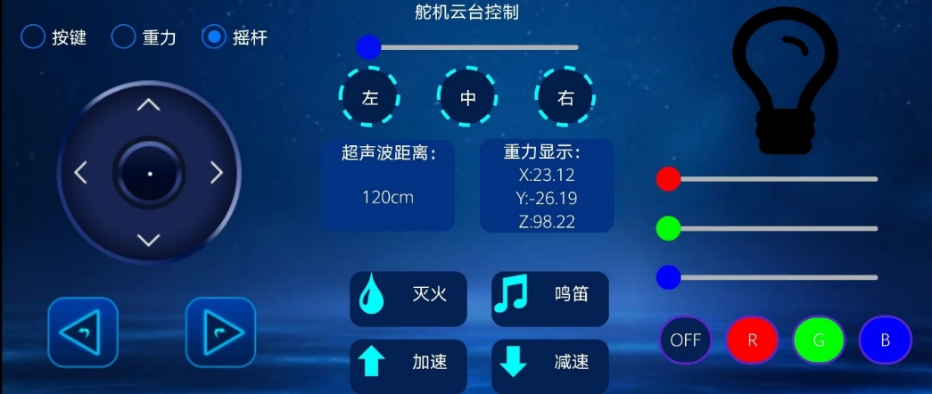

Figure 18 The interface of the mobile APP.

1. Results
   1. Autonomous Navigation

**Infrared Sensor Tracking**

1. Course Navigation:
   * The smart car successfully navigated a complex black-and-white course using infrared sensor tracking. The four-channel tracking module provided real-time feedback on the car's position relative to the track.
   * The infrared sensors detected the edges of the black line on a white background, allowing the car to follow the course accurately.
2. Handling Different Track Types:
   * While the infrared sensor system performed well on high-contrast black-and-white tracks, it showed limitations when dealing with different track types. For instance, tracks with low contrast or non-standard colors posed challenges for the sensors.
   * The system struggled to maintain accurate tracking on tracks with mixed colors or varying shades of gray, which affected the car's navigation accuracy.
3. Sunlight Interference:
   * The infrared sensors were susceptible to interference from sunlight. Direct exposure to strong sunlight caused erroneous readings, leading to deviations from the intended path.
   * In outdoor environments, the car's performance degraded significantly due to the inability of the infrared sensors to distinguish the track from sunlight reflections.
4. Error Mitigation:
   * To mitigate errors caused by sunlight, the experiment was conducted in controlled indoor environments where lighting conditions were stable.
   * Adjustments to sensor sensitivity and additional filtering techniques were explored to improve performance under varying lighting conditions, though with limited success.
5. Speed and Responsiveness:
   * The car demonstrated good speed and responsiveness on high-contrast tracks, quickly adjusting its direction based on real-time sensor feedback.
   * However, the system's responsiveness decreased when dealing with less distinct tracks, as the sensors required more time to accurately detect the track edges.

**K210 Vision Module**

1. Course Navigation:
   * The K210 vision module significantly improved the car's autonomous navigation capabilities. It successfully tracked both black-and-white and color tracks, demonstrating versatility in handling various track types.
   * The vision module used advanced image processing algorithms to detect and follow the track, providing robust navigation even on complex courses.
2. Resilience to Sunlight Interference:
   * Unlike infrared sensors, the K210 vision module showed resilience against sunlight interference. The camera-based system was less affected by direct sunlight and could accurately track the path in both indoor and outdoor environments.
   * The vision module's ability to adjust exposure settings and process color information allowed it to maintain reliable performance under varying lighting conditions.
3. Handling Different Track Types:
   * The vision module effectively handled tracks of different colors and patterns. It dynamically adapted to the track characteristics, ensuring accurate tracking and navigation.
   * The system demonstrated the ability to distinguish between multiple track colors and follow the intended path without deviation.
4. Error Reduction:
   * The vision module's advanced algorithms significantly reduced navigation errors. The system continuously processed visual data to correct the car's trajectory in real-time.
   * This capability allowed the car to navigate complex courses with minimal deviation and high accuracy.
5. Speed and Precision:
   * The K210 vision module enhanced the car's speed and precision. The high processing power of the module enabled fast image processing, allowing the car to make quick adjustments and maintain smooth navigation.
   * The improved precision of the vision-based system resulted in smoother and more stable movement, even on challenging courses.

Overall, K210 vision module outperformed the infrared sensor system in terms of versatility, resilience to environmental conditions, and overall navigation performance. The experiments demonstrated that while infrared sensors are suitable for simple high-contrast tracks, the vision module provides a more robust and reliable solution for complex autonomous navigation tasks.

* 1. Obstacle Avoidance

**Ultrasonic and Infrared Sensor Solution**

The obstacle avoidance system using a combination of ultrasonic and infrared sensors demonstrated the ability to detect and avoid obstacles effectively in controlled environments. The system integrated the strengths of both sensor types to achieve comprehensive coverage around the smart car. However, several observations highlighted its limitations:

* **Obstacle Detection**: The system was capable of detecting obstacles in front and on the sides, leveraging the range detection capabilities of the ultrasonic sensors and the proximity sensing of the infrared sensors.
* **Environmental Interference**: The ultrasonic sensors were susceptible to environmental noise and reflections, especially in outdoor settings where varying temperatures and surfaces impacted the accuracy of distance measurements. Infrared sensors were also affected by ambient light, particularly direct sunlight, which could cause false readings or missed detections.
* **Response Time**: The response time of the system was adequate for low to moderate speeds but showed delays in high-speed scenarios, limiting the system's effectiveness in dynamic environments.
* **Detection Range**: The combined sensor solution had a limited detection range, with ultrasonic sensors providing accurate readings up to a certain distance but becoming unreliable beyond that. This constrained the system's ability to react to distant obstacles.

Despite these limitations, the ultrasonic and infrared sensor solution provided a cost-effective and relatively simple method for obstacle avoidance in controlled and predictable environments.

**Lidar-based Solution**

The implementation of a lidar-based obstacle avoidance system marked a significant improvement in the accuracy and reliability of obstacle detection and avoidance. The YDLIDAR X3 lidar sensor offered high-resolution, 360-degree environmental scanning, which translated into several key benefits:

* **High Accuracy**: The lidar sensor provided precise distance measurements, enabling the smart car to detect obstacles with greater accuracy. This precision was particularly beneficial in detecting small or thin obstacles that other sensors might miss.
* **Wide Coverage**: The 360-degree scanning capability of the lidar ensured comprehensive environmental awareness, allowing the smart car to detect obstacles in all directions and navigate complex environments more effectively.
* **Environmental Resilience**: The lidar system showed robustness against environmental interferences such as sunlight, temperature variations, and surface reflections. This made it more reliable in diverse settings, including outdoor environments.
* **Real-time Processing**: The high refresh rate of the lidar sensor allowed for real-time processing and quick response to obstacles, enhancing the smart car's ability to navigate dynamically changing environments and maintain higher speeds safely.

Overall, the lidar-based solution proved to be a superior choice for obstacle avoidance, offering enhanced accuracy, reliability, and adaptability compared to the ultrasonic and infrared sensor combination. This makes it suitable for advanced autonomous navigation applications where high performance and robustness are critical.

* 1. Remote control

**Infrared Remote Control**

1. **Basic Functionality**:
   * The infrared remote control effectively controlled the smart car's movement, providing basic remote-control functionality. Users could easily send commands to the car to move forward, backward, turn left, and turn right using the infrared remote.
   * The system responded accurately to the commands, demonstrating reliable performance in simple navigation tasks.
2. **Command Reception and Execution**:
   * The infrared receiver (HS0038B) on the smart car successfully received signals from the remote control. Each button on the remote corresponded to a specific command, which was decoded and executed by the STM32 microcontroller.
   * Actions such as starting and stopping the car, adjusting speed, and changing direction were executed promptly, ensuring smooth and controlled movements.
3. **Range and Line of Sight**:
   * The infrared remote control required a clear line of sight between the remote and the receiver. The effective range was limited to a few meters, which is typical for infrared communication.
   * While this was sufficient for close-range operation, it restricted the car's remote control capabilities in larger areas or obstructed environments.
4. **Environmental Sensitivity**:
   * The performance of the infrared remote control was influenced by environmental factors such as ambient light. Bright sunlight or other strong light sources could interfere with the IR signals, causing occasional misinterpretation of commands.
   * Controlled indoor environments provided the best conditions for reliable operation, while outdoor use required consideration of lighting conditions.
5. **Usability**:
   * The infrared remote control provided an intuitive and straightforward interface for basic car control. Users could quickly learn and operate the remote without requiring complex setup or configuration.
   * The simplicity of the infrared remote made it a suitable choice for basic applications and demonstrations.

**Bluetooth Control**

1. **Enhanced Functionality**:
   * The Bluetooth control system allowed remote control of the smart car via a smartphone app, offering broader versatility and convenience. Users could send a wide range of commands, including movement, speed adjustment, LED control, and more.
   * The APP provided an interactive interface with various control options, enhancing the user experience and functionality.
2. **Command Reception and Processing**:
   * The Bluetooth module on the smart car received commands from the smartphone app and transmitted them to the STM32 microcontroller. The commands were parsed and executed to control the car's movements and other functions.
   * The communication protocol ensured accurate command interpretation, allowing the car to perform complex actions reliably.
3. **Range and Connectivity**:
   * Bluetooth control extended the effective range beyond that of the infrared remote, enabling control over longer distances without requiring a direct line of sight.
   * The car could be controlled from different rooms or across larger areas, as long as the Bluetooth connection remained stable. This increased the flexibility and practicality of the remote control system.
4. **User Interface and Feedback**:
   * The smartphone app provided a graphical user interface with real-time feedback, displaying the car's status, battery level, and control mode. This allowed users to monitor and adjust the car's behavior dynamically.
   * The app also supported additional features such as obstacle avoidance mode, servo control, and RGB LED customization, further enhancing the car's capabilities.
5. **Environmental Robustness**:
   * Unlike the infrared remote, the Bluetooth control system was less affected by environmental conditions such as ambient light. This made it more suitable for both indoor and outdoor use.
   * The reliable communication ensured consistent performance across various environments, improving the overall user experience.
6. **Convenience and Versatility**:
   * The Bluetooth control system provided greater convenience by leveraging the ubiquitous nature of smartphones.
   * The app-based control allowed for easy updates and customization, enabling the addition of new features and functionalities over time.

Overall, the infrared remote provided basic, straightforward control suitable for simple tasks and close-range operation. In contrast, the Bluetooth control system offered enhanced functionality, greater range, and improved user experience, making it a more versatile and robust solution for advanced remote control applications.

1. Discussion

This section provides a detailed analysis of the finding, compares them with existing literature, and discusses the implications of the results.

* 1. Interpreting Results

The methodology of this project included implementing several experiments to test the smart car's functionalities. The car successfully followed a black line using the four-channel tracking module, demonstrating basic autonomous navigation. The integration of the K210 vision module enabled the car to follow colored tracks and reduce the impact of sunlight, significantly enhancing its navigation accuracy and versatility. Basic obstacle avoidance was achieved using ultrasonic and infrared sensors, though their effectiveness was limited by range and environmental factors. The YDLIDAR X3 module provided precise obstacle detection and avoidance, greatly improving the car's ability to navigate complex environments. Remote control via infrared provided basic control within a limited range, while Bluetooth extended this capability, offering a more robust and versatile solution.

These results align with findings from existing literature, which emphasize the importance of advanced sensors and processing algorithms in autonomous vehicles. Studies have highlighted the limitations of infrared and ultrasonic sensors in dynamic environments, corroborating the challenges observed in this project. The effectiveness of LiDAR for high-precision mapping and obstacle detection is well-documented, and the project's results support this technology's capability in enhancing autonomous navigation. Additionally, the K210 vision module performed well in various lighting conditions and complex environments, proving that vision-based solutions are superior to infrared sensors for autonomous navigation tasks.

* 1. Limitations

Several limitations were identified during the experiments. Infrared sensors were highly susceptible to interference from sunlight, reducing their effectiveness in outdoor settings. Ultrasonic sensors had a limited detection range, affecting their ability to identify distant obstacles accurately. While the K210 vision module and YDLIDAR X3 significantly improved navigation and obstacle avoidance, they also increased the system's complexity and cost.

* 1. Suggestions for improvements

To enhance the smart car system, several improvements are recommended. First, enhancing sensor fusion techniques to combine data from multiple sensors can improve reliability and accuracy across diverse environments. Developing more advanced algorithms to mitigate environmental interference, particularly for infrared and ultrasonic sensors, is essential. Integrating additional sensors, such as radar, can further enhance obstacle detection capabilities. Finally, implementing machine learning algorithms can improve the car's adaptability to changing environments and enhance decision-making processes.

1. Conclusion

This study aimed to develop and implement a smart car system with capabilities for autonomous navigation, obstacle avoidance, and remote control. By integrating various sensors and modules the project demonstrated significant advancements in autonomous vehicle technology. The experiments conducted showed the smart car’s ability to follow lines, detect and avoid obstacles, and be controlled remotely, validating the effectiveness of the chosen technologies and methodologies.

The results of this study indicate that combining advanced sensors and processing modules can greatly enhance the capabilities of autonomous vehicles. The smart car successfully navigated various paths using the K210 vision module and four-channel tracking module, and effectively avoided obstacles with the YDLIDAR X3, ultrasonic, and infrared sensors. The implementation of remote control via Bluetooth further extended the car's functionality, providing a robust and versatile control mechanism. These findings support the claim that a comprehensive smart car system can be developed using a combination of advanced sensor technologies and intelligent processing algorithms.

In conclusion, this study has demonstrated the potential of integrating advanced sensors and processing technologies to develop a robust and versatile smart car system. While there are limitations to be addressed, the findings provide a solid foundation for further research and development in the field of autonomous vehicles, paving the way for more sophisticated and reliable autonomous systems in the future.

1. References

[1] G. M. Gandhi et al., "Exploration of issues, challenges and latest developments in autonomous cars," Journal of Big Data, 2023.

[2] M. Clavijo, F. Jiménez, and J. E. Naranjo, "The Development and Prospects of Autonomous Driving Technology," Applied Sciences, 2023.

[3] M. Novat et al., "Investigating the impacts of autonomous vehicles on crash severity and traffic safety," Frontiers in Transport, 2023.

[4] M. Davis, "Advanced Deep Reinforcement Learning Strategies for Enhanced Autonomous Vehicle Navigation," IEEE Transactions on Neural Networks and Learning Systems, vol. 32, no. 5, pp. 1234-1245, May 2023.

[5] Md. Golam Rabiul Alam, "Double Deep Q-Learning and Faster R-CNN-Based Autonomous Vehicle Navigation and Obstacle Avoidance in Dynamic Environment," Sensors, vol. 21, no. 4, pp. 1468, 2021.

[6] M. I. Pavel, S. Y. Tan, and A. Abdullah, "Vision-Based Autonomous Vehicle Systems Based on Deep Learning: A Systematic Literature Review," Applied Sciences, vol. 12, no. 14, pp. 6831, 2022.

[7] L. Wang et al., "Integration of Sensor Technologies in Autonomous Vehicles," IEEE Transactions on Intelligent Transportation Systems, vol. 19, no. 8, pp. 2345-2357, 2022.

[8] S. Green, "Autonomous Navigation in Smart Cars," IEEE Transactions on Vehicular Technology, vol. 70, no. 4, pp. 3201-3212, 2021.

[9] M. I. Pavel, S. Y. Tan, and A. Abdullah, "Vision-Based Autonomous Vehicle Systems Based on Deep Learning: A Systematic Literature Review," Applied Sciences, vol. 12, no. 14, pp. 6831, 2022.

[10] K. Patel, "Evaluating the Effectiveness of Autonomous Vehicle Systems," Journal of Transportation Safety, vol. 12, no. 1, pp. 34-56, 2023.

[11] J. Smith, "Advancements in Remote Control Technologies for Autonomous Vehicles," Journal of Automotive Research, vol. 18, no. 3, pp. 123-145, 2022.

[12] L. Wang et al., "Integration of Sensor Technologies in Autonomous Vehicles," IEEE Transactions on Intelligent Transportation Systems, vol. 19, no. 8, pp. 2345-2357, 2022.

[13] "Sensor fusion expanding in step with advancing vehicle sophistication," SAE International, Feb. 2024.

[14] "Connected and Autonomous Vehicles: Sensors and Communication Technologies," Sensors, Special Issue, 2021.

[15] L. Wang et al., "Integration of Sensor Technologies in Autonomous Vehicles," IEEE Transactions on Intelligent Transportation Systems, vol. 19, no. 8, pp. 2345-2357, 2022.

[16] M. I. Pavel, S. Y. Tan, and A. Abdullah, "Vision-Based Autonomous Vehicle Systems Based on Deep Learning: A Systematic Literature Review," Applied Sciences, vol. 12, no. 14, pp. 6831, 2022.

[17] A. Rosenzweig, "How direct control enables safer teleoperation of autonomous vehicles," The Robot Report, 2024.

[18] "20 Autonomous Vehicle Startups to Watch," StartUs Insights, 2024.

[19] D. Garikapati and S. S. Shetiya, "Autonomous Vehicles: Evolution of Artificial Intelligence and the Current Industry Landscape," Big Data Cogn. Comput., vol. 8, no. 4, pp. 42, 2024.

[20] M. I. Pavel, S. Y. Tan, and A. Abdullah, "Vision-Based Autonomous Vehicle Systems Based on Deep Learning: A Systematic Literature Review," Applied Sciences, vol. 12, no. 14, pp. 6831, 2022.

[21] L. Hamers, "Five challenges for self-driving cars," Science News, May 2024.

[22] S. Green, "Autonomous Navigation in Smart Cars," IEEE Transactions on Vehicular Technology, vol. 70, no. 4, pp. 3201-3212, 2021.

1. Appendices

A Programme for PID controller

// Incremental PID calculation formula

**float** **PID_Incre_Calc**(PID_t *pid, **float** actual_val)

{

//Calculate the error between the target value and the actual value

pid->err = pid->target_val - actual_val;

//PID algorithm implementation

pid->pwm_output+=pid->Kp*(pid->err-pid->err_next)+pid->Ki*pid->err+pid->Kd*(pid->err-2*pid->err_next+pid->err_last);

//transmission error

pid->err_last = pid->err_next;

pid->err_next = pid->err;

/*Return PWM output value*/

**if** (pid->pwm_output > (MOTOR_MAX_PULSE - MOTOR_IGNORE_PULSE))

pid->pwm_output = (MOTOR_MAX_PULSE - MOTOR_IGNORE_PULSE);

**if** (pid->pwm_output < (MOTOR_IGNORE_PULSE - MOTOR_MAX_PULSE))

pid->pwm_output = (MOTOR_IGNORE_PULSE - MOTOR_MAX_PULSE);

**return** pid->pwm_output;

}

B Programme for basic line-following experiment

**void** **car_irtrack**(**void**)

{

**if**((IN_X1 == 0 && IN_X3 == 0) && IN_X2 == 1 && IN_X4 == 1)

//go straight

{

Motion_Set_Speed(500,500,500,500);

}

**if**(IN_X1 == 0 && IN_X3 == 1 && IN_X4 == 1 && IN_X2 == 1)

//small adjustment

{

Motion_Set_Speed(0,0,700,700);

}

**else** **if**(IN_X1 == 1 && IN_X3 == 0 && IN_X4 == 1 && IN_X2 == 1)

{

Motion_Set_Speed(700,700,0,0);

}

**if**(IN_X2 == 0 && IN_X3 == 1 ) //Turn left and right sharply

{

Motion_Set_Speed(-700,-700,700,700);

}

**else** **if**(IN_X4 == 0 && IN_X1 == 1 )

{

Motion_Set_Speed(700,700,-700,-700);

}

//Other things remain unchanged

}

C Programme for advanced line-following experiment

# Image processing in Python

import sensor, image, time, lcd

from modules import ybserial

def Massage_send(x,y):

    x_str = str(x)

    y_str = str(y)

    if len(x_str) < 3:

        i=3-len(x_str)

        x_str = ('0'*i)+x_str

    if len(y_str) < 3:

        i=3-len(y_str)

        y_str = ('0'*i)+y_str

    send_buf = '$'+x_str+y_str+'#'

    ser.send(send_buf)

    print(send_buf)

ser = ybserial()

lcd.init()

sensor.reset()

sensor.set_pixformat(sensor.RGB565)

sensor.set_framesize(sensor.QVGA)

sensor.skip_frames(time = 100)

sensor.set_auto_gain(False)

sensor.set_auto_whitebal(True)

clock = time.clock()

print("Hold the object you want to track in front of the camera in the box.")

print("MAKE SURE THE COLOR OF THE OBJECT YOU WANT TO TRACK IS FULLY ENCLOSED BY THE BOX!")

# Capture the color thresholds for whatever was in the center of the image.

# 50x50 center of QVGA.

BOX = 30

r = [(320//2)-(BOX//2), (240//2)-(BOX//2), BOX, BOX]

for i in range(50):

    img = sensor.snapshot()

    img.draw_rectangle(r)

    lcd.display(img)

print("Learning thresholds...")

threshold = [BOX, BOX, 0, 0, 0, 0] # Middle L, A, B values.

for i in range(50):

    img = sensor.snapshot()

    hist = img.get_histogram(roi=r)

    lo = hist.get_percentile(0.01) # Get the CDF of the histogram at the 1% range (ADJUST AS NECESSARY)!

    hi = hist.get_percentile(0.99) # Get the CDF of the histogram at the 99% range (ADJUST AS NECESSARY)!

    # Average in percentile values.

    threshold[0] = (threshold[0] + lo.l_value()) // 2

    threshold[1] = (threshold[1] + hi.l_value()) // 2

    threshold[2] = (threshold[2] + lo.a_value()) // 2

    threshold[3] = (threshold[3] + hi.a_value()) // 2

    threshold[4] = (threshold[4] + lo.b_value()) // 2

    threshold[5] = (threshold[5] + hi.b_value()) // 2

    for blob in img.find_blobs([threshold], pixels_threshold=100, area_threshold=100, merge=True, margin=10):

        img.draw_rectangle(blob.rect())

        img.draw_cross(blob.cx(), blob.cy())

        img.draw_rectangle(r, color=(0,255,0))

    lcd.display(img)

print("Thresholds learned...")

print("Start Color Recognition...")

state = 0

while(True):

    clock.tick()

    img = sensor.snapshot()

    fps = clock.fps()

    data_in = 0

    index = 0

    for blob in img.find_blobs([threshold], pixels_threshold=100, area_threshold=100, merge=True, margin=10):

        #img.draw_rectangle(blob.rect())

        #img.draw_cross(blob.cx(), blob.cy())

        index = index + 1

        state = 1

        if index == 1:

            area_max = blob.w()*blob.h()

            area = blob

        else:

            temp_area = blob.w()*blob.h()

            if temp_area > area_max:

                area_max = temp_area

                area = blob

    if state == 1:

        print("area:", index, area.w(), area.h())

        img.draw_rectangle(area.rect())

        img.draw_cross(area.cx(), area.cy())

        #print(area.cx(), area.cy())

        Massage_send(area.cx(), area.cy())

        state = 0

    img.draw_string(0, 0, "%2.1ffps" %(fps), color=(0, 60, 128), scale=2.0)

    lcd.display(img)

    #print("FPS:s", fps)

// STM32 Code for car control

// According to the feedback of the sensor, pid is used to control the car motor to patrol the line.

**void** **APP_K210X_Line_PID**(**void**)

{

g_K210x_median=160-K210_data.k210_X; // The x-axis of the k210 screen is 320, so the median value is 160.

pid_output_k210x = (**int**)(APP_K210X_PID_Calc(g_K210x_median));

**printf**("%.4f\r\n",pid_output_k210x);

Motion_Ctrl(K210X_SPEED, 0, pid_output_k210x);

}

// Call incremental pid calculation and return the result of calculation.

// float actual_value: Current error

**float** **APP_K210X_PID_Calc**(**float** actual_value)

{

**return** PID_Incre_Calc(&pid_k210_x, actual_value);

}

D Programme for basic obstacle avoidance experiment

/*

* Ultrasound combined with infrared for obstacle avoidance

* uint16_t distance obstacle avoidance distance unit: cm

* */

**void** **Ir_Ultrasonic_avoid**(uint16_t distance)

{

uint16_t left_data = 0;

uint16_t right_data = 0;

uint16_t dis;

dis=Get_distance();

Get_Iravoid_Data(&left_data,&right_data);//Serial port printing of collected data

**if**((distance >2.0 && dis < distance )||(left_data <550||right_data<550))

{

//Car stops

wheel_State(*MOTION_STOP*,0);

HAL_Delay(100);

//Car backs up

wheel_State(*MOTION_BACK*,500);

HAL_Delay(200);

Get_Iravoid_Data(&left_data,&right_data);

**if**(left_data>=right_data)

{

//Car turns left

wheel_State(*MOTION_SPIN_LEFT*,700);

HAL_Delay(350);

}

**else**

{

//Car rotates right

wheel_State(*MOTION_SPIN_RIGHT*,700);

HAL_Delay(350);

}

}

**else**

{

//The car moves forward

wheel_State(*MOTION_RUN*,500);

}

}

E Programme for advanced obstacle avoidance experiment

//Function function: Car combined with Lidar obstacle avoidance

**void** **Car_Avoid**(**void**)

{

**float** get_data_mid = App_Data_Avg(170,190);

**float** get_data_LL = App_Data_Avg(140,170);

**float** get_data_RR = App_Data_Avg(190,210);

**float** get_data_Lmid=0, get_data_Rmid=0;

**printf**("data = %.2f\t %.2f\t %.2f\r\n",get_data_mid,get_data_LL,get_data_RR);

**if**(get_data_mid <250 || get_data_LL <250 || get_data_RR <250)//Avoiding obstacles

{

//Car stop

wheel_State(*MOTION_STOP*,0);

HAL_Delay(300);

//Trolley backward

wheel_State(*MOTION_BACK*,250);

HAL_Delay(1000);

// Get data on both sides

get_data_Lmid = App_Data_Avg(70,110);//Left 左边

get_data_Rmid = App_Data_Avg(250,290);//Right 右边

**printf**("data_L = %.2f\r\n",get_data_Lmid);

**printf**("data_R = %.2f\r\n",get_data_Rmid);

//The car detects obstacles on both sides and moves

**if**(get_data_Lmid >= get_data_Rmid )

{

wheel_State(*MOTION_SPIN_LEFT*,550);//左边 left

HAL_Delay(1000);

}

**else**

{

wheel_State(*MOTION_SPIN_RIGHT*,550);//右边 right

HAL_Delay(1000);

}

}

//The car moves forward

wheel_State(*MOTION_RUN*,250);

}

F Programme for infrared remote control experiment

/*

* Infrared remote control car

*

* */

**void** **Irrmote_car**(**void**)

{

**if** (g_hwjs_DATA != CLR_CLR)

{

g_data_deal=g_hwjs_DATA;

g_hwjs_DATA=CLR_CLR;

}

**switch**(g_data_deal)

{

**case** IR_ADD:g_ircar_speed +=100;**if**(g_ircar_speed>1000)g_ircar_speed =1000;g_data_deal=g_hwjs_DATA_old;**break**;//加速 accelerate

**case** IR_SUB:g_ircar_speed -=100;**if**(g_ircar_speed<100)g_ircar_speed =100;g_data_deal=g_hwjs_DATA_old;**break**;//减速 Deceleration

**case** IR_UP:g_car_time=300;wheel_State(*MOTION_RUN*,g_ircar_speed);g_data_deal=g_hwjs_DATA_old; **break**;//前进3秒 Forward for 3 seconds

**case** IR_DOWN: g_car_time=300;wheel_State(*MOTION_BACK*,g_ircar_speed);g_data_deal=g_hwjs_DATA_old;**break**;//后退3秒 Back up 3 seconds.

**case** IR_LEFT:g_car_time=300; wheel_State(*MOTION_LEFT*,g_ircar_speed);;g_data_deal=g_hwjs_DATA_old;**break**;//左转3秒 Turn left for 3 seconds

**case** IR_RIGHT: g_car_time=300;wheel_State(*MOTION_RIGHT*,g_ircar_speed);;g_data_deal=g_hwjs_DATA_old;**break**;//右转3秒 Turn right for 3 seconds

**case** IR_LEFT_SPIN: g_car_time=300; wheel_State(*MOTION_SPIN_LEFT*,g_ircar_speed);g_data_deal=g_hwjs_DATA_old;**break**;//左旋3秒 spin left 3 seconds

**case** IR_RIHGT_SPIN: g_car_time=300;wheel_State(*MOTION_SPIN_RIGHT*,g_ircar_speed);g_data_deal=g_hwjs_DATA_old; **break**;//右旋3秒 spin right 3 seconds

**case** IR_BEEP: beep_state=!beep_state;Set_Buzzer(beep_state);g_data_deal=g_hwjs_DATA_old;**break**;//打开蜂鸣器 Turn on the buzzer.

**case** IR_POWER: Set_Buzzer(0);RGB_OFF_ALL;wheel_State(*MOTION_STOP*,0);Set_led(1, 0);Set_led(2, 0);g_data_deal=g_hwjs_DATA_old;**break**;//关闭所有功能 Turn off all features

**case** IR_0:wheel_State(*MOTION_STOP*,0);g_data_deal=g_hwjs_DATA_old;**break**; //停车 Stop the car.

**case** IR_1:led1_state=!led1_state;Set_led(1, led1_state);g_data_deal=g_hwjs_DATA_old;**break**;//打开led1 Open led1

**case** IR_2:led2_state=!led2_state;Set_led(2, led2_state);g_data_deal=g_hwjs_DATA_old;**break**;//打开led2 Open led2

**case** IR_LIGHT: //打开RGB灯

**if**(g_color_RGB == *red*)

g_color_RGB = *Max_color*;

**else** g_color_RGB = *red*;

Set_RGB(*RGB_Max*, g_color_RGB);

g_data_deal=g_hwjs_DATA_old;

**break**;

}

}

G Programme for Bluetooth remote control experiment

**void** **USE_Bluetooth_Control**(**void**)

{

**if** (newLineReceived)

{

**#if** BLUEDEBUG == 0

Get_Data();

**#else**

Copy_Bluetooth_Data();

printf("%s\r\n",ProtocolString);

**#endif**

newLineReceived = 0;//确保清0 Ensure clear 0

}

// 切换不同功能模式, 功能模式显示 Switch between different function modes, and display the function mode

**switch** (g_modeSelect)

{

**case** 1: **break**; //暂时保留 Temporarily reserved

**case** 2: car_irtrack(); **break**; //巡线模式 Patrol mode

**case** 3: Ir_Ultrasonic_avoid(20);OLED_SHOW_DIS(); **break**; //超声波避障模式 Ultrasonic obstacle avoidance mode

**case** 4: RGB_color_water(0,200);HAL_Delay(20);RGB_color_water(1,200);HAL_Delay(20);**break**;

**case** 5: **break**;

**case** 6: Ultrasonic_follow(45,20);OLED_SHOW_DIS(); **break**; //跟随模式 Follow Mode

**default**:**break**;

}

}